

Tribhuvan University
Faculty of IOST

Library Record Keeping System
C Programming

Submitted To
Department of IOST
Orchid International College

Submitted By
Group: B
Lok Raj Kalouni
Kriti Pandey
Kumari Hema Bhatta
Krish Thapa Magar
CSIT 1st Sem

1.Acknowledgment
We, the undersigned members of the project, would like to express our sincere gratitude to our respected teacher, Mr. Nabin Dhital, for his valuable guidance, encouragement and feedback throughout the completion of our project titled “Library Record Keeping System” in the subject of C Programming.
We are deeply thankful to Orchid International College for providing us with the opportunity to work on this project. This project has been an invaluable learning experience, allowing us to apply theoretical knowledge to practical implementation.
We also extend our appreciation to all faculty members and friends who offered suggestions, motivation, and assistance during the course of this project. Their cooperation made the journey smoother and more collaborative.
Finally, we acknowledge the collective effort of our group members, whose dedication, teamwork, and commitment ensured the successful completion of this project.

Table of Contents
Page No.
1. Acknowledgment ....................................................................................... 1
2. Introduction ............................................................................................... 3
3. Objectives .................................................................................................. 4
4. Methodology ............................................................................................. 5-6
5. Output ....................................................................................................... 7-11
6. Conclusion ................................................................................................ 12

2. Introduction
The project titled “Library Record Keeping System” is developed to address this challenge by creating a structured way to store, organize, and retrieve book-related data. The system focuses on simplifying tasks such as counting books by category, listing books issued after a certain date, finding the most and least expensive books, and displaying records by author.
This project was carried out as part of our C Programming coursework, where we combined theoretical concepts with practical implementation. To build the system, we utilized structures for representing book records, arrays for handling multiple entries, functions for modular design, and file handling for persistent storage. We also integrated simple graphics to make the output visually clear and engaging.
The development process was collaborative, with each team member contributing to different aspects such as coding, debugging, and testing. We adopted GitHub for version control, which allowed us to work on separate branches and merge our contributions efficiently. Visual Studio Code served as our primary development environment, while Turbo C++ was used to execute the program with graphical output.
By working on this project, we not only strengthened our programming skills but also gained valuable experience in teamwork, project organization, and problem-solving. More importantly, the project gave us a practical understanding of how digital systems can streamline record management in real-world scenarios like libraries.

3.Objectives
The main objectives of the “Library Record Keeping System” project are:
- Efficient Data Management: To design a system that can store, organize, and retrieve book records in a structured manner.
- Functional Operations: To implement features such as counting books by category and price, listing books issued after a specific date, identifying the most and least expensive books, and displaying books by specific author.
- Application of C Programming Concepts: To apply core programming concepts including structures, arrays, functions, pointers, file handling, switch cases, and loops for practical problem-solving.
- Graphics Integration: To enhance the user interface by incorporating simple graphics using Turbo C++ for clearer and more engaging output.
- Team Collaboration: To develop the project collaboratively, practicing teamwork, version control with GitHub, and efficient workflow management.
- Skill Development: To strengthen problem-solving abilities, debugging skills, and gain hands-on experience in building a real-world inspired record management system.

4.Methodology
The development of the “Library Record Keeping System” followed a systematic approach, ensuring that each stage contributed to building a functional and user-friendly program. The methodology can be summarized as follows:
- Defined Structure:
A nested structure using struct keyword was created to represent book records, including fields such as book name, author name, category, price, and issue date. This provided a clear and organized way to store and access data.
- Defined Functions and Pointer:
Distinct user-defined functions such as void addbooks(), void display_books(), etc. were created by the group members for their respective task. A file pointer was also created for opening the file in different modes.
- Menu-Driven Program:
A menu-driven interface was designed to allow users to select different operations, such as searching, adding and displaying book records. This modular approach made the system easy to navigate.
- User Input:
The system was designed to take input directly from the user, enabling flexibility in adding new records and testing different scenarios.
- Data Storage:
Book records were stored in arrays, allowing efficient handling of multiple entries, enabling operations such as sorting and filtering, and using file handling for persistent storage using book.txt file.
- Logic Implementation:
  - Find most expensive & least expensive book:
The program using the function most_and_least_expensive() iterates through array and compares price of the books using conditional operators to determine the most expensive and least expensive books from the data written in saved books.txt file.

  - Display books by specific author:
The program using function named as book_by_author() first asks the first and last name of the author to search and then compares it with the data present in the saved books.txt file and if the name matches then the details of book by specific author is shown as output.
  - Show books issued after 01-01-2026:
A function name as books_after_date() was created in which issued date was created in DD-MM-YYYY format using day, month, and year as integer variable. The program filters the issued dates by comparison using conditional as well as relational operators and display the book details which were issued after 01-01-2026.

  - Count books per category:
The program uses function named as count_books_per_category() in which the category of book was counted using distinct integer variable defining the category of books and increasing its value by one if the category name matches with the data saved in books.txt file.
- Formatted Output with Graphics:
To enhance readability and presentation, outputs were displayed in a formatted style using basic graphics in Turbo C++. Rectangles with filled color, and aligned text were used to make the results visually clear and engaging.
- Development and Collaboration:
The project was developed using Visual Studio Code. Each team member worked individually on separate branches, and the code was later merged into the main branch using GitHub, ensuring proper version control and collaboration.

5.Output
Here, we have added our input and output(screenshots):

Stored data for the Library Record Keeping System:

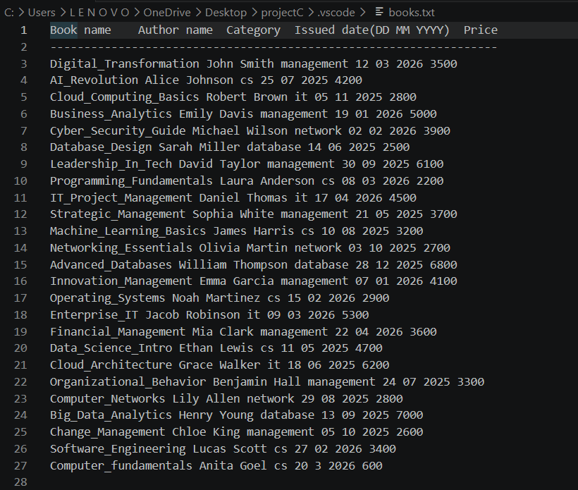

To find most expensive & least expensive book:
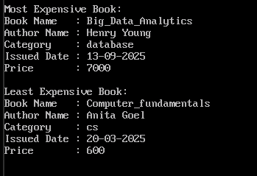

To display books by specific author:
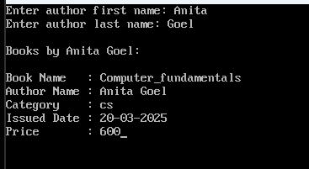

To show books issued after 01-01-2026:
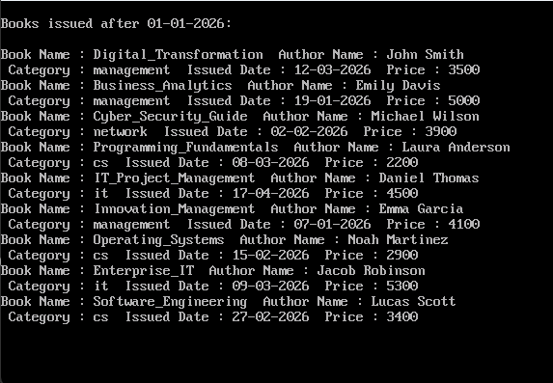

To count books per category:
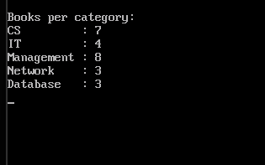

To display the output in graphics format using Turbo C++:
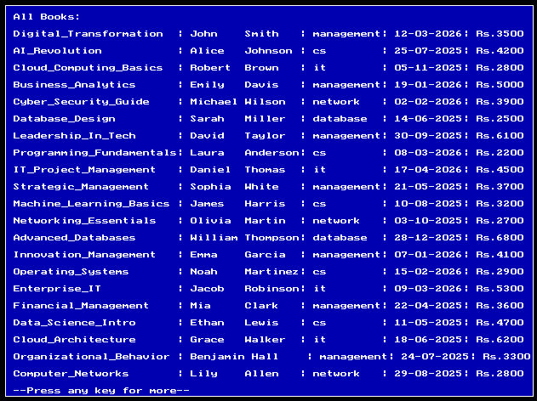

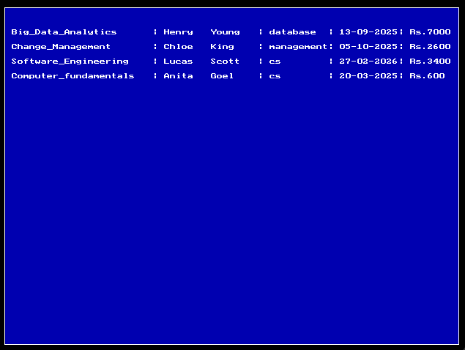

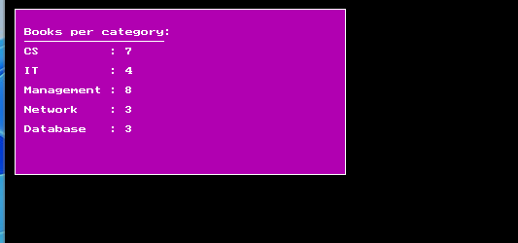
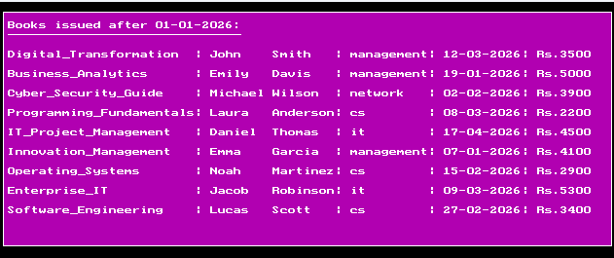
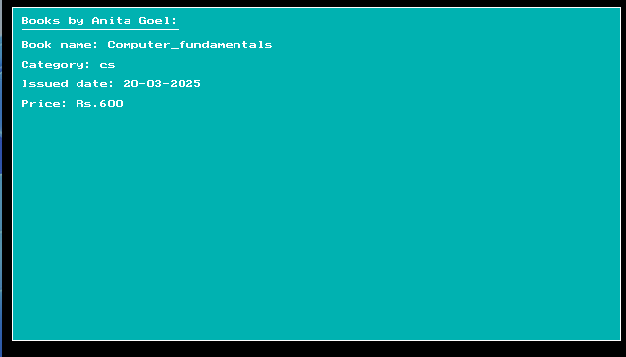
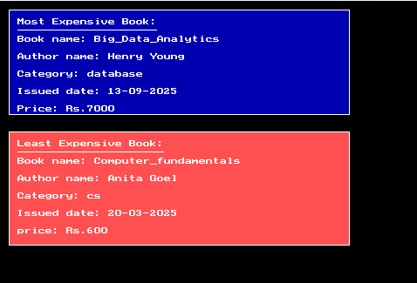

6.Conclusion
The “Library Record Keeping System” project helped us understand how programming can be used to manage information in a simple and organized way. By using C programming concepts like structures, arrays, functions, pointers, file handling, and graphics we were able to create a system that stores book records and performs tasks such as searching, filtering, and finding specific details.
Working on this project improved our practical skills in coding, debugging, and teamwork. We also learned how to use GitHub for version control and Turbo C++ for adding graphics to make the output more attractive. Overall, the project gave us both technical knowledge and real experience in solving problems through programming.

